

# UNIVERSITY OF PETROLEUM & ENERGY STUDIES

**Dehradun**

ACO LAB

**NAME- RADHIKA RAJESH THAKKAR**

**BRANCH- COMPUTER SCIENCE ENGINEERING BATCH- B-4 DEVOPS**

**SAP ID- 500098212 ROLL NO- R2142211496**

**SUBMITTED TO- Dr. Hitesh Kumar Sharma**

**EXPERIMENT-5**

# AIM : Working with Dockerfile to Build and Push Docker Image Steps to Complete:

1. Create following Dockerfile

FROM alpine MAINTAINER SUDIPT

RUN apk update RUN apk add nodejs RUN mkdir /app COPY index.js /app WORKDIR /app

RUN node index.js

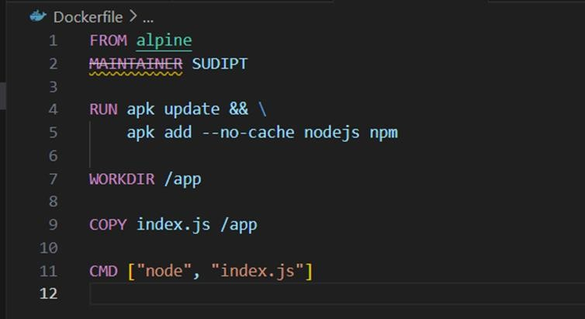

1. Now we have dockerized the app, we will Build image from Dockerfile.

## “ docker build -t myimage:1.0.0 . ”

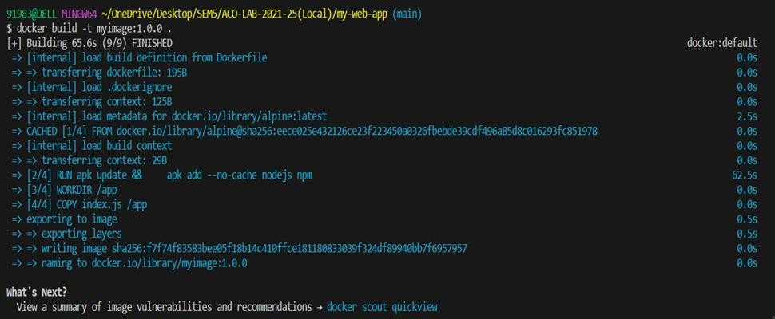

1. Create account on Dockerhub and create a repository in it.

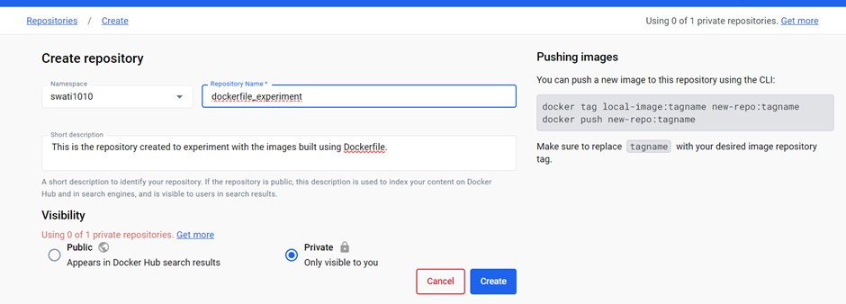

1. Tag the recently created image using following command.

## “ docker tag imageID Repositoryname ”



1. Login to Dockerhub from console using following command.

## “ docker login ”

